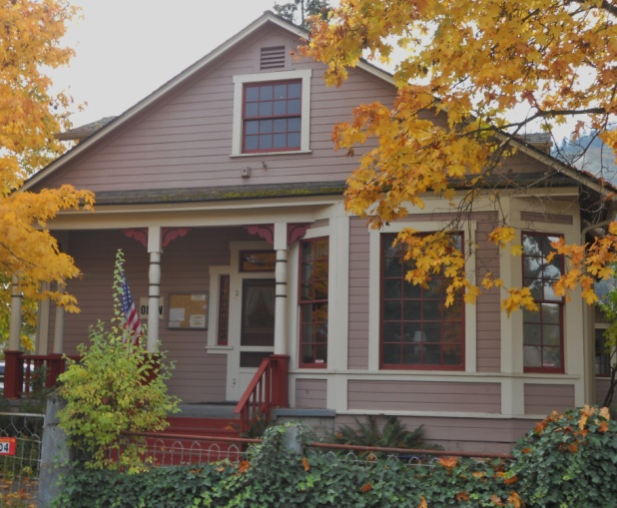
Gold Hill Historical Society
“Saving the Past For The Future”
P. O. Box 26
Gold Hill, OR 97525
541-855-1182 Email:goldhillmuseum@qwestoffice.net
MEMBERSHIP APPLICATION
Name:____________________________________________________________
Mailing Address:___________________________________________________
City/State/Zip Code:_________________________________________________
Phone Number:_________________Email:_______________________________

Annual Family Membership $20.00
Mark One:
_____New Member _____Renewal _____Donation

As a GHHS member, IF, you would like to volunteer below is a list of ways you can assist in the continued growth and success of the Gold Hill Museum.
____Be a Museum greeter ____occasionally ____on a regular schedule
____Help with yard work and plant care
____Help with special events (Easter egg hunt, Gold Dust Day, Haunted House etc.)
____Help obtaining and/or transcribing oral histories
____Assist with housekeeping at the Museum
____Assist with light carpentry/electrical/masonry/mechanical, painting repairs
____Assist with displays, inventory artifacts, accession donations etc.
____Other?___________________________________________________________________

Memberships, donations and volunteers are what keep the door to our museum open, you are greatly appreciated!

Museum hours are Thursday through Saturday from noon to 4:00 p.m.
Monthly meetings: third Wednesday, 6:30 p.m. at the Museum (except September)

